**LAB 4**

**Q1. Print all alphabets in upper case and in lower case**

print("Name: KanavShahPatel")

print("Roll Number: 24BEE107")

fori in range (65,91):

print(chr(i),end =" ")

print("")

fori in range (97,123):

print(chr(i),end=" ")

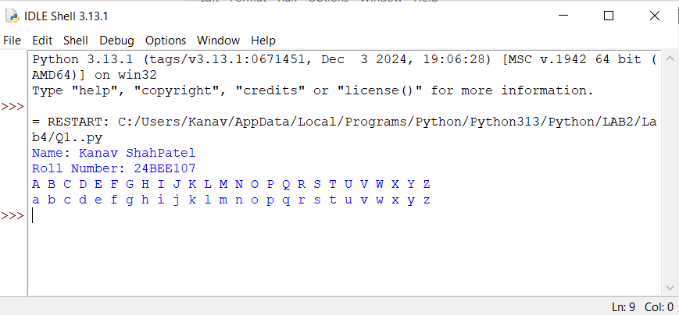

**Q2. Print a multiplication table of a given number**.

print("Name: KanavShahPatel")

print("Roll no: 24BEE107")

a = int(input("Enter the number of which the table you want"))

print(f"The table of {a} is")

fori in range (1,11):

print(a*i)

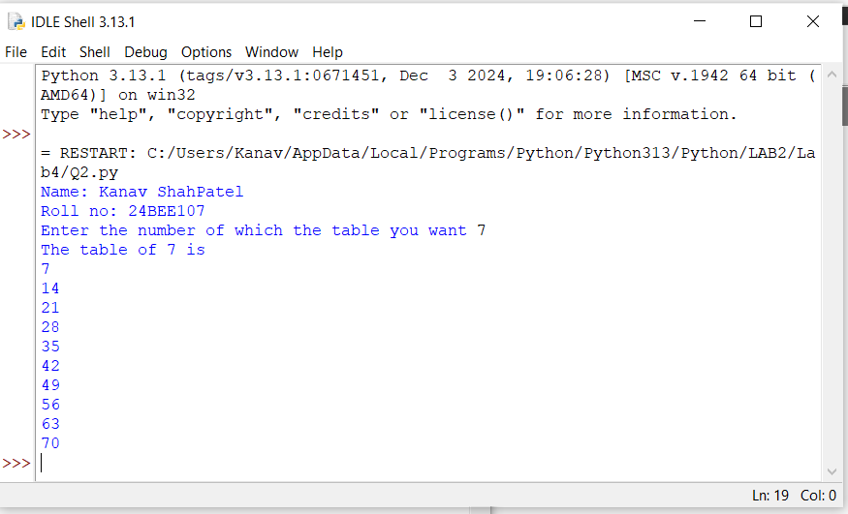

**Q3. Count no. of alphabets and no. of digits in any given string.**

print("Name: KanavShahPatel")

print("Roll Number: 24BEE107")

a = input("Enter a string")

b = len(a)

a.lower()

c=0

d=0

fori in a:

if('a'<= i<= 'z'):

c+=1

else:

d+=1

print(f"The number of alphabets is {c}")

print(f"The number of digits is {d}")

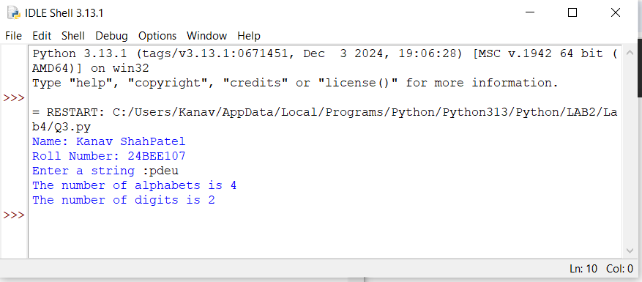

**Q4. Check whether a given number is prime, is perfect, is Armstrong, is palindrome, is automorphic.**

print("Name: KanavShahPatel")

print("Roll no: 24BEE107")

num = int(input("Enter a number"))

defarmstrong(a):

n=0

sum=0

f=a

while(a>0):

n=a%10

sum=(n*n*n)+sum

a=a//10

if f==sum:

print(f"{f} is an Armstrong number")

else:

print(f"{f} is not an armstrong number")

armstrong(num)

def prime(a):

c=0

fori in range (1,a+1):

if(a%i==0):

c+=1

if(c==2):

print(f"{a} is a prime number")

else:

print(f"{a} is not a prime number")

prime(num)

def palindrome(a):

f=a

rev=0

n=0

while(a>0):

n=a%10

rev=rev*10+n

a//=10

if(f==rev):

print(f"{f} is a palindrome number")

else:

print(f"{f} is not a palindrome number")

palindrome(num)

def perfect(a):

sum=0

fori in range (1,a):

if(a%i==0):

sum= sum + i

if(sum==a):

print(f"{a} is a perfect number")

else:

print(f"{a} is not a perfect number")

perfect(num)

def automorphic(a):

square = a*a

lasttwo = square%100

if(a==lasttwo):

print(f"{a} is an automorphic number")

else:

print(f"{a} is not an automorphic number")

automorphic (num)

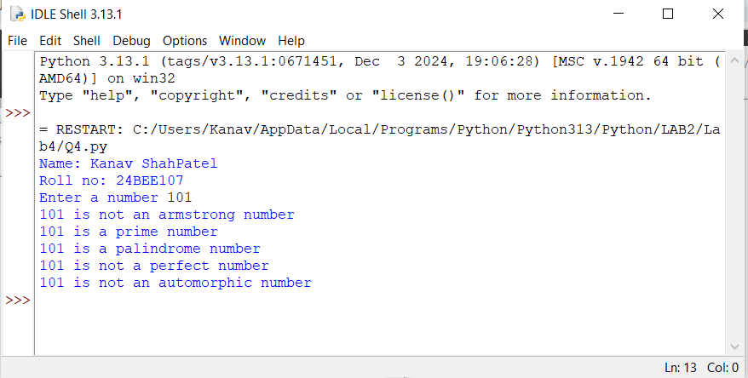

**Q5. Generate all Pythagorean Triplets with side length <= 30.**

print("Name: KanavShahPatel")

print("Roll Number: 24BEE107")

for a in range (1,31):

for b in range (a+1,31):

for c in range (b+1,31):

if((a*a)+(b*b)==(c*c)):

print(f"Thepythagorean triplet is {a},{b},{c}")

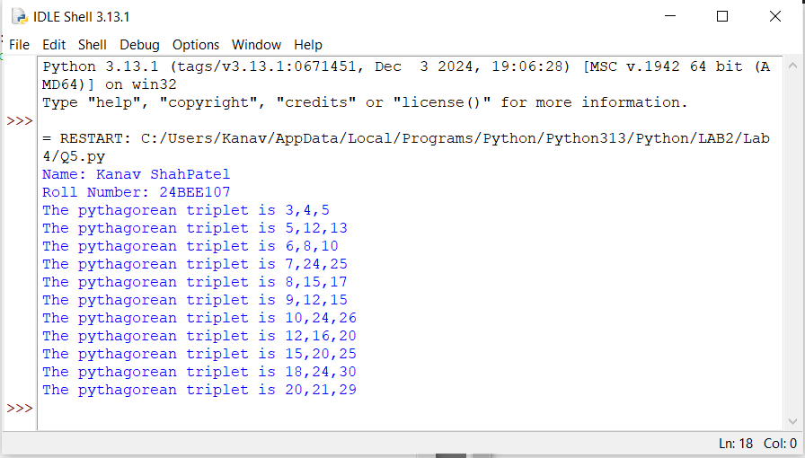

**Q6. Print 24 hours of day with suitable suffixes like AM, PM, Noon and Midnight.**

print("Name: KanavShahPatel")

print("Roll Number: 24BEE107")

defprint_day_with_suffixes():

for hour in range(24):

if hour == 0:

print(f"12:00 AM - Midnight")

elif hour == 12:

print(f"12:00 PM - Noon")

elif hour < 12:

print(f"{hour}:00 AM")

else:

print(f"{hour - 12}:00 PM")

print_day_with_suffixes()

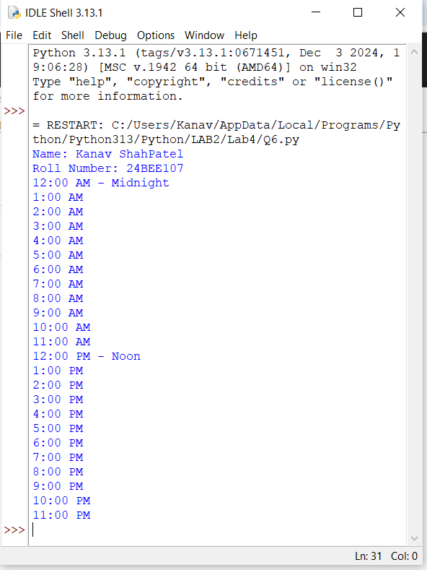

**Q7. Print nCr and nPr.**

print("Name: KanavShahPatel")

print("Roll Number: 24BEE107")

n = int(input("Enter the value of n"))

r =int(input("Enter the value of r"))

defnCr(a,b):

fact =1

ract=1

tact=1

fori in range (1,a+1):

fact = fact*i

for j in range (1,b+1):

ract=ract*j

for k in range(1,(a-b)+1):

tact=tact*k

l = ract *tact

k=fact//l

print(f"ThenCr value is {k} ")

nCr(n,r)

defnPr (a,b):

fact =1

tact =1

fori in range (1,a+1):

fact = fact *i

for j in range (1,(a-b)+1):

tact=tact*j

f = fact//tact

print(f"ThenPr value is {f}")

nPr(n,r)

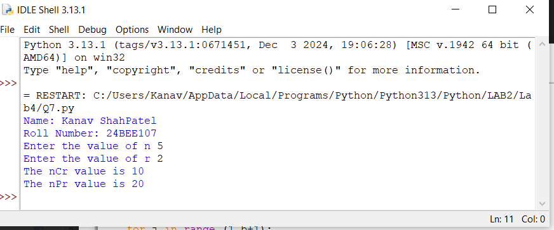

**Q8. Print factorial of a given number.**

print("Name: KanavShahPatel")

print("Roll Number: 24BEE107")

a = int(input("Enter a number"))

fact =1

fori in range (1,a+1):

fact = fact*i

print(f"The factorial of number {a} is {fact}")

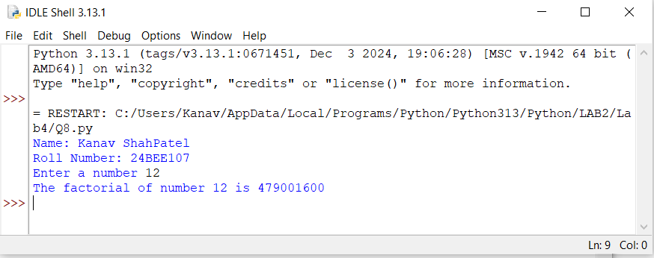

**Q9. Print N natural nos. in reverse.**

print("Name: KanavShahPatel")

print("Roll Number: 24BEE107")

a = int(input("Enter the terms upto which you want the series"))

print("The series in reverse is :")

fori in range (a,0,-1):

print(i,end =" ")

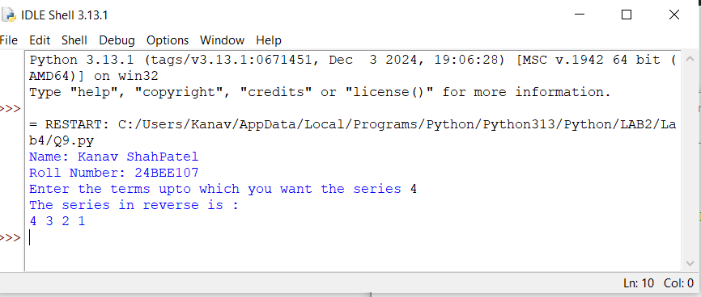

**Q10. Generate N numbers of Fibonacci series.**

print("Name: KanavShahPatel")

print("Roll Number: 24BEE107")

a = int (input("Enter the first number"))

b=int(input("Enter the second number"))

n = int (input("Enter the range of the series"))

c=0

while(c<=n):

c=a+b

print(c ,end=" ")

a=b

b=c

c+=1

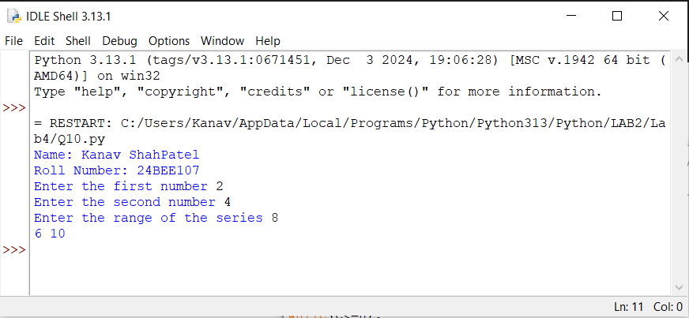

**Q11. Calculate sin(x); x is a radian value. The formula is as under:**

$$\sin{x=x- \frac{x^{3}}{3!}}+ \frac{x^{5}}{5!}- \frac{x^{7}}{7!}…$$

print("Name: KanavShahPatel")

print("Roll Number: 24BEE107")

import math

angle = int(input("Enter the value of angle in degrees"))

rad = angle*(3.14//180)

result=0

n = int(input("Enter the range of the series"))

fori in range (0,n+1):

power = 2*i+1

term = (((-1)**i)*(rad**power))/math.factorial(power)

result+=term

print(result)

